# Using VS Code & Submitting Files

Throughout this course, you will be writing code and submitting it to your instructor. In today’s lesson, we will review the procedure to:

* open VS Code
* create a file
* save a file and eject your USB safely

VS Code Procedure Overview

Each of the following steps is explained in detail on the following pages. As you repeat the steps, you will become more familiar with them, and so we’ve offered this quick reference guide so that you can check the steps quickly and easily in the future.

*Plug In Procedure Un-Plug Procedure*

1. Turn on your computer 1. Save all
2. Log into student account 2. Exit VS Code
3. Insert USB drive 3. Safe-eject USB drive
4. Launch VS Code 4. Remove USB drive
5. Open folder to F:\Lesson101
6. Create new Java file

Plug In Procedure

**Content  
Collaboration Tools for programming**

In this activity you will learn the correct procedures for using a USB drive to store and transport your programs. The USB drive also provides an opportunity for you to collaborate with others and share your programs.

Can you think of other ways that you might collaborate with others in this course as you create and share programs? What methods are used in the field of programming when there are a number of programmers working on developing the same software application?

Turn on & Login

1. Turn on the computer and wait for it to power up.
2. If prompted for login, your teacher will give you your username and password. Record your username and password here for safekeeping:

username: password:

Insert USB Drive

1. Insert USB drive
2. Some Windows messages might appear—ignore them.

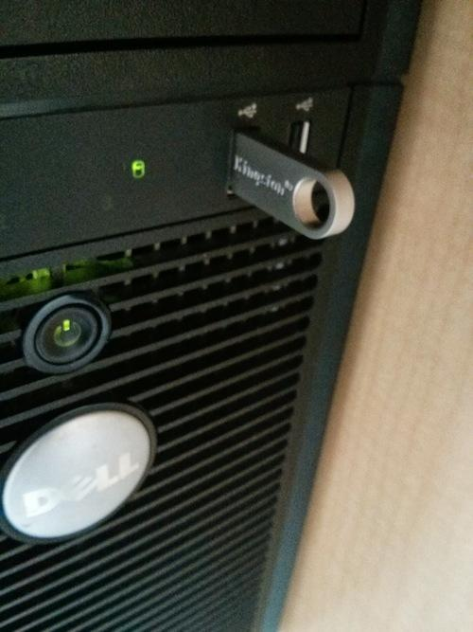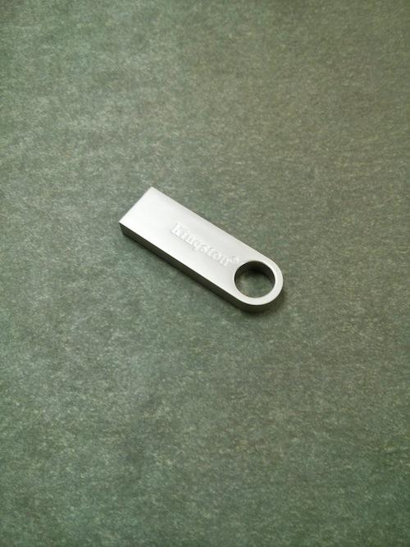

Start VS Code

1. Double-click on the VS Code Icon on the desktop
2. Click “Open Folder…”

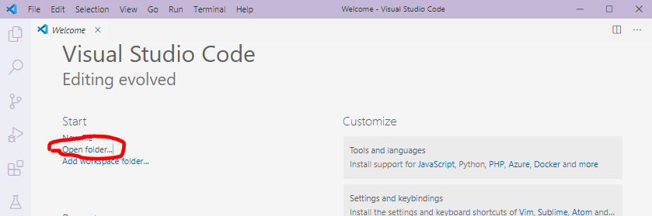

1. Select your USB Drive.

Create New Folder

1. To keep organized, create a new folder for each lesson, right click on Drive and select “New Folder”, enter “Lesson1.01” and press “Enter”.

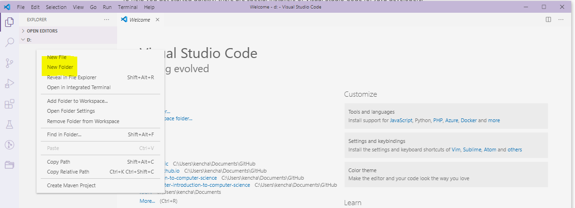

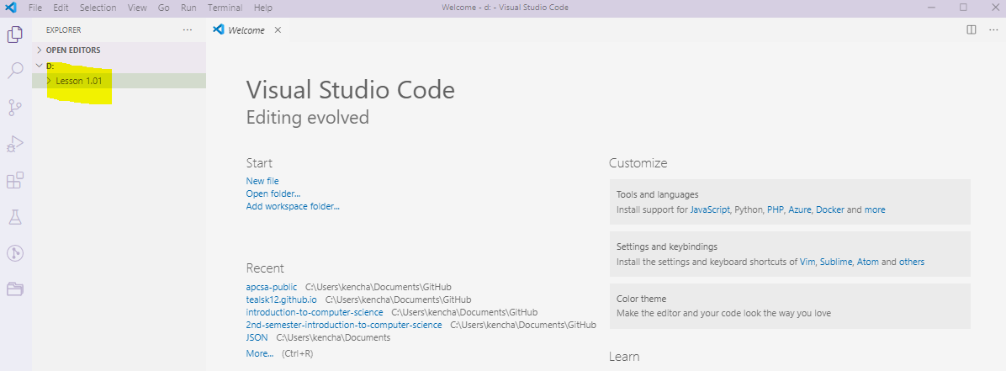

1. Create a new file to enter a program, right click under folder “Lesson1.01” and enter “HelloWorld.java” and press “Enter”.

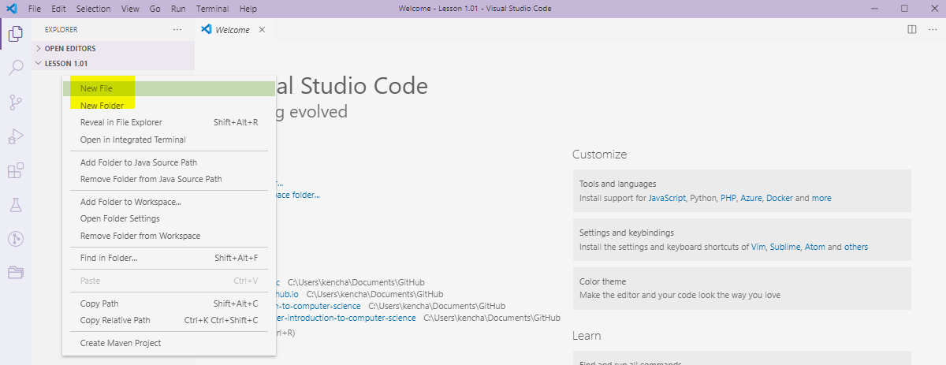

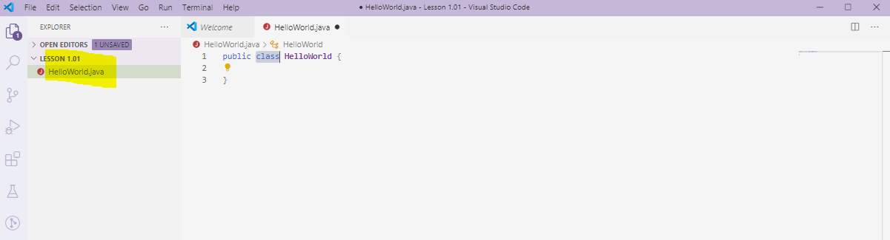

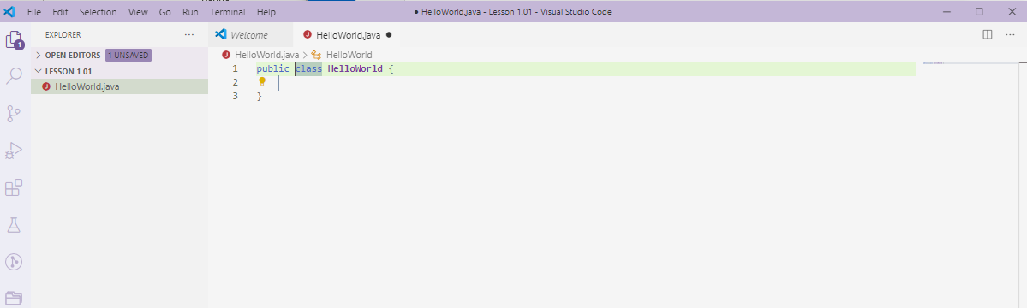

Enter and Running Your Program

1. Type the following line of code after   
   public class HelloWorld {

public static void main (String[] args) {

System.out.println (“Hello World”);

}

1. Save file with Ctrl-S
2. Click on the Run Icon
3. Look for output in the Console Window.   
     
   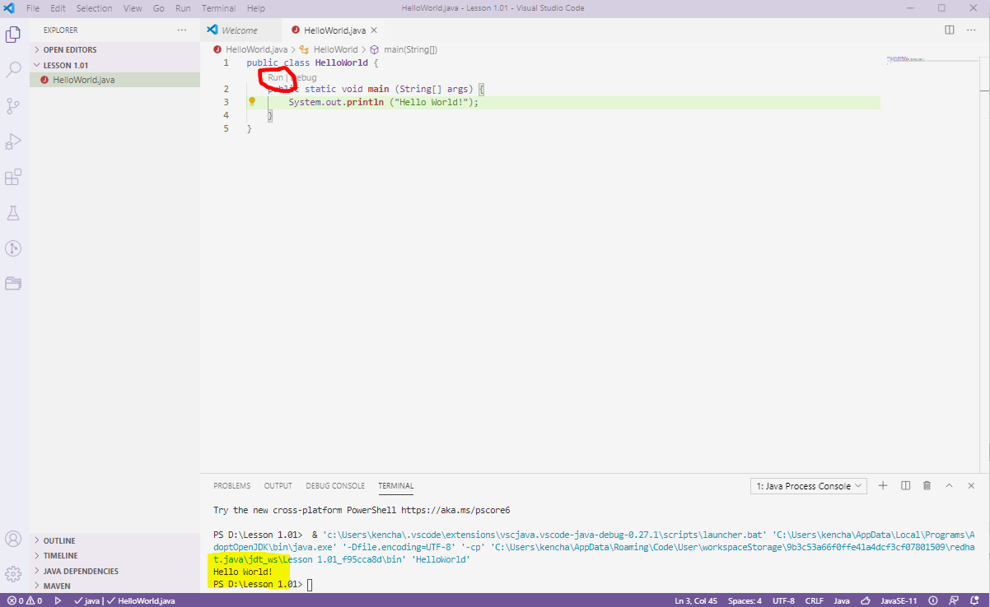

Un-Plug Procedure

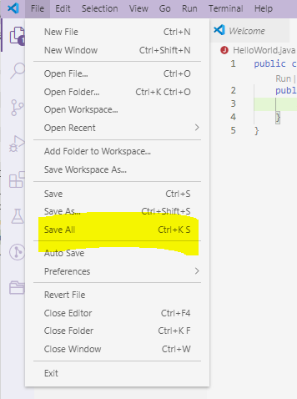

Save All

1. Click on File > Save All to

save all edited files.

The keyboard shortcut is Ctrl+K S

*This text might be greyed-out*

*and not-clickable if all files*

*have already been saved.*

Exit VS Code

1. Select File > Exit

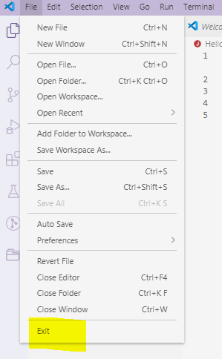

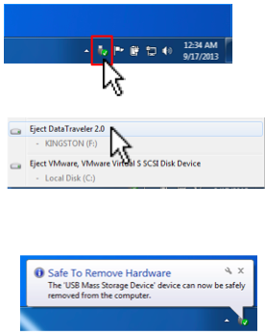Safe-Eject USB Drive

1. Click on the Devices icon in the

lower-right corner of the screen.

1. Select Eject Data Traveler
2. Wait for Safe to Remove Hardware

message.

Remove USB Drive

6. Remove the USB Drive from the Computer. Don’t forget to take it with you, and be sure to bring it back to class each day!

